- AIM and SCOPE
The aim of this guide is to determine, instruct on, and ensure unity in the principles and rules applied to the writing of the graduation projects in Fenerbahçe University, Department of English Language and Literature undergraduate program.
- EXPRESSION and STYLE
In the project, what is meant to be explained should be expressed clearly, long and complex sentences should be avoided, sentences should be correct in terms of spelling, and words should be used appropriately. Sentences should be grammatically and ideologically correct, simple, clear and harmonious, and words should be chosen well. The connection between sentences and paragraphs should be well-made, this connection should not be broken with off-topic expressions, and care should be taken to establish the necessary connections in transitions from chapter to chapter. Possessive words (I did, I saw, I found, in our study, research, science, etc.) should not be used unless necessary. Instead, words that express third person and passive voice (done, in this study, in the area, etc.) should be preferred.
Quotations in the graduation projects should not be given in a way that occupies one page or more one after the other. Either the criticisms, comments or explanations of the author of the assignment should be included among the quotations- this is among the criteria in the evaluation of the author’s writing and comprehension level.
- PAGE LAYOUT and MARGINS
Set the margins of your document to 2,5 cm on all sides. Margins settings are made on the “page setup” tab in the “page layout” window.
- FONT and SIZE
In the writing of the project, size 12 in Times New Roman font should be used. Block quotations, tables, figures, pictures, graphics, etc. should also be given in size 12 and Times New Roman. In the parts of the assignment that require special emphasis by the author, italic font can be used.
- FOOTNOTES and ENDNOTES
Since MLA formatting style does not employ footnotes and endnotes extensively, they should not be preferred unless encouraged by the advisor.

- Page Numbering
Page numbers should be in size 12, Times New Roman, centred at the bottom of each page, one-half inch from the bottom. Pages up to the introduction section should not be numbered. The page including the introduction section should start with 1 (one).
- Paragraph and Line Spacing
Pages should be justified, line spacing throughout the project should be set to double (2).
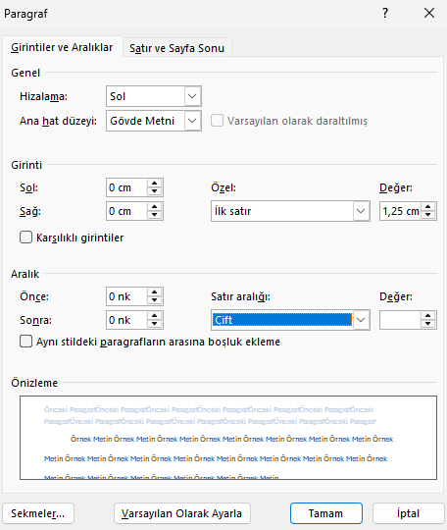

- Line and Line Break
The lines at the beginning of the page and at the end of the page should not remain single. In such cases, the following setting should be made by selecting the relevant paragraph.
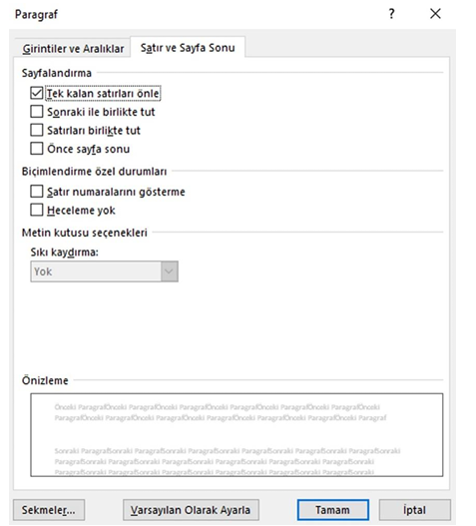
- Sections, Subsections and Headings
Types of information that make up the content in the assignment are clustered into various sections and subsections. Each new section in the assignment text should start on a new page. The numbers of each chapter are written in Arabic numerals.
The whole body of the project including the headings, the Abstract title, the abstract body and the Works cited page are set to size 12.
As given in the MLA directives, you may follow one of the heading systems below in a consistent manner:
Numbered:
1. Soil Conservation
1.1 Erosion
1.2 Terracing
2. Water Conservation
3. Energy Conservation

Formatted, unnumbered:
Level 1 Heading: bold, flush left
Level 2 Heading: italics, flush left
Level 3 Heading: centered, bold
Level 4 Heading: centered, italics
Level 5 Heading: underlined, flush left

- Tables, Figures and Examples
Because MLA style is most often used in the humanities, it is unlikely that you will include raw scientific data in an MLA-style paper, but you may be asked to include other kinds of research in your writing. MLA Tables, Figures, and Examples - Purdue OWL® - Purdue University
Refer to the table and its corresponding numeral in-text. Do not capitalize the word table. This is typically done in parentheses. Situate the table near the text to which it relates. Align the table flush-left to the margin. Label the table 'Table' and provide its corresponding Arabic numeral. No punctuation is necessary after the label and number. On the next line, provide a caption for the table, most often the table title. Use title case. Place the table below the caption, flush-left, making sure to maintain basic MLA style formatting (e.g. one-inch margins). Below the title, signal the source information with the descriptor "Source," followed by a colon, then provide the correct MLA bibliographic information for the source in note form (see instructions and examples above). If you provide source information with your illustrations, you do not need to provide this information on the Works Cited page.
If additional caption information or explanatory notes is necessary, use lowercase letters formatted in superscript in the caption information or table. Below the source information, indent, provide a corresponding lowercase letter (not in superscript), a space, and the note. Labels, captions, and notes are double-spaced.
- Textual Format
Graduation papers basically consist of the cover page, abstract, the main body, references (Works cited), and the appendices (if there is any data provided in non-textual form).
Cover page template is attached to the end of this document.
Table of Contents: Denotes the page number of each section. All section headings in the assignment text should be given here.
Abstract: The title “Abstract” is given in size 12, centred. The abstract body should be justified, 12 in size. The abstract comprises of the purpose, scope, method used and conclusions of the assignment, all of which should be written clearly and concisely. The abstract should not exceed 250 words. Under the abstract, 5 keywords denoting the content of the study are specified on a single line, separated from each other with a comma and first letter capitalized, with the subheading "Keywords".
Main Body: The introduction is the first element of the body of the project. Therefore, the pages of the assignment text are numbered starting with the Introduction. In this section, the scientific problem intended to be discussed in the study should be stated. The scope of the research, the method(s) applied, the main ideas, methods and results of the previous studies about the assignment and the current approach to the subject, and the information preparing the reader for the subject are included with synthesized summaries in an orderly manner.
The section of the assignment between the Introduction and the Conclusion is the main text. After the Introduction, there are sections of the main text. In these chapters, depending on the level of detail required, the information and explanations leading the assignment to the conclusion are put forward in the appropriate sequence of thoughts. Unnecessary details are not given.
Conclusion: The last part of the assignment is the "Conclusion". In this section, starting from the purpose and/or hypothesis explained in the introduction, the method, technique and the solution reached within the framework of the limitations of the assignment are explained by making use of the conclusions reached in various sections. These explanations are also supported by various suggestions that will shed light on further studies when necessary. In addition, if there are problems that cannot be solved in the research, information can be given about what type or subject of research can be used to solve it in the future. The general conclusions reached in the study are written as concisely as possible, but clearly within the framework of a certain order and logic; following a comparison with other studies on the relevant subject, the validity and applicability of the conclusions reached are stated.
References (Works cited): Referencing is an indispensable element of scientific study. It is done
a) to show that a part of another work was benefited from during the study at hand,
b) in cases where a specific section, sentence, concept, etc. of another study is affected by the whole study or the general judgment of that study is criticized or evaluated,
c) in order to show that certain parts of other studies are evaluated, criticized, etc., and are used during the study.
The main purpose here is to show the sources on which the author relied, criticized or discussed in constructing their argument and position. MLA formatting style (9th edition) should be employed in all forms of referencing in the assignment. https://owl.purdue.edu/owl/research_and_citation/mla_style/mla_formatting_and_style_guide/index.html
- In-text citations: Please refer to
https://owl.purdue.edu/owl/research_and_citation/mla_style/mla_formatting_and_style_guide/mla_in_text_citations_the_basics.html.
- Works cited: All the sources used in the assignment are included here. Literature that is not mentioned in the body of the assignment should not be included in the list of the works cited. Please refer to
https://owl.purdue.edu/owl/research_and_citation/mla_style/mla_formatting_and_style_guide/mla_works_cited_page_basic_format.html.


FENERBAHÇE UNIVERSITY
FACULTY OF ADMINISTRATIVE, ECONOMICS AND SOCIAL SCIENCES
DEPARTMENT OF ENGLISH LANGAUGE AND LITERATURE
GRADUATION PROJECT

TITLE OF ASSIGNMENT

AUTHOR
Name Surname
Number

ADVISOR
Title Name Surname

ISTANBUL, 20..

